Interest Form
IE expo China 2018 “Trade Fair for Environmental Technology Solutions”
Shanghai, 3rd – 5th May 2018

Company Profile questionnaire to be filled out in all parts and to be sent to espositori@monacofiere.com by 28th February 2018

Company Name:
Sector of activity:
Address:
Zip code: | Town: |  |  | Country:
Website: |  |  | No. of employees:
Turnover: |  |  | Year of foundation:
Contact person
Surname: |  | Name:
Tel.: |  | Fax:
E-mail: |  | Mobile ph. (in use at the exhibition):

Short Abstract of company profile
Describe the innovative solution/technology
Describe clearly the environmental benefits of the solution mentioned above
Do you intend to exhibit any technology | YES 𛲝 NO 𛲝  If yes, please describe dimension needed for the exhibition
Interest in B2B | YES 𛲝 NO 𛲝
Additional service requests  Interpreter for B2B | YES 𛲝 NO 𛲝
Describe the type of collaboration you are interested in (export -import, licensing, joint venture, franchising etc.)

ORGANIZING SECRETARIAT:
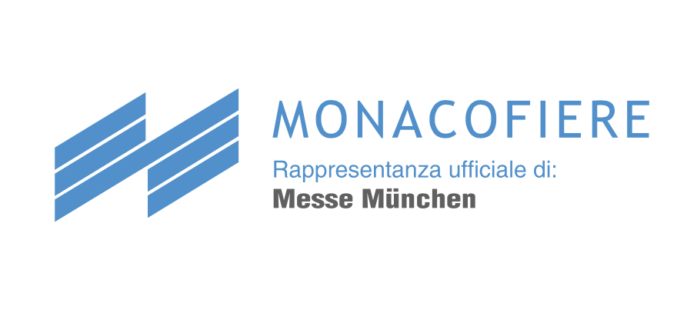 | MONACOFIERE Rappr. ufficiale In Italia MESSE MÜNCHEN INTERNATIONAL  mail: espositori@monacofiere.com; tel: +39 02 4070 8301; fax: +39 02 8736 9039  www.monacofiere.com

